**INPUT OUTPUT DOCUMENT**

ON

**ONLINE LLR APPLICATION SYSTEM**

**BY**

**Sudharsan K**

**EMPLOYEE-ID: 46127834**

**PROJECT CODE: OLAS-01**

**MAIL-ID:** [**sudharsan.a.k@capgemini.com**](mailto:sudharsan.a.k@capgemini.com)

|  |  |
| --- | --- |
| **Project Code:** | OLAS-01 |
| **Project Name:** | Online LLR Application System |

1. SC1MAP

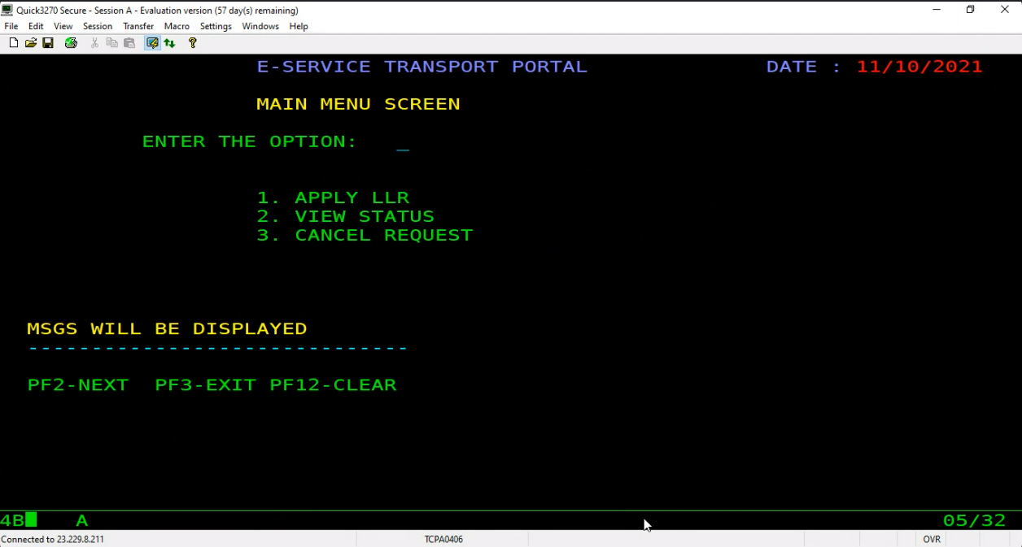

* 1. SC1MAP – INVALID OPTIONS ENTERED

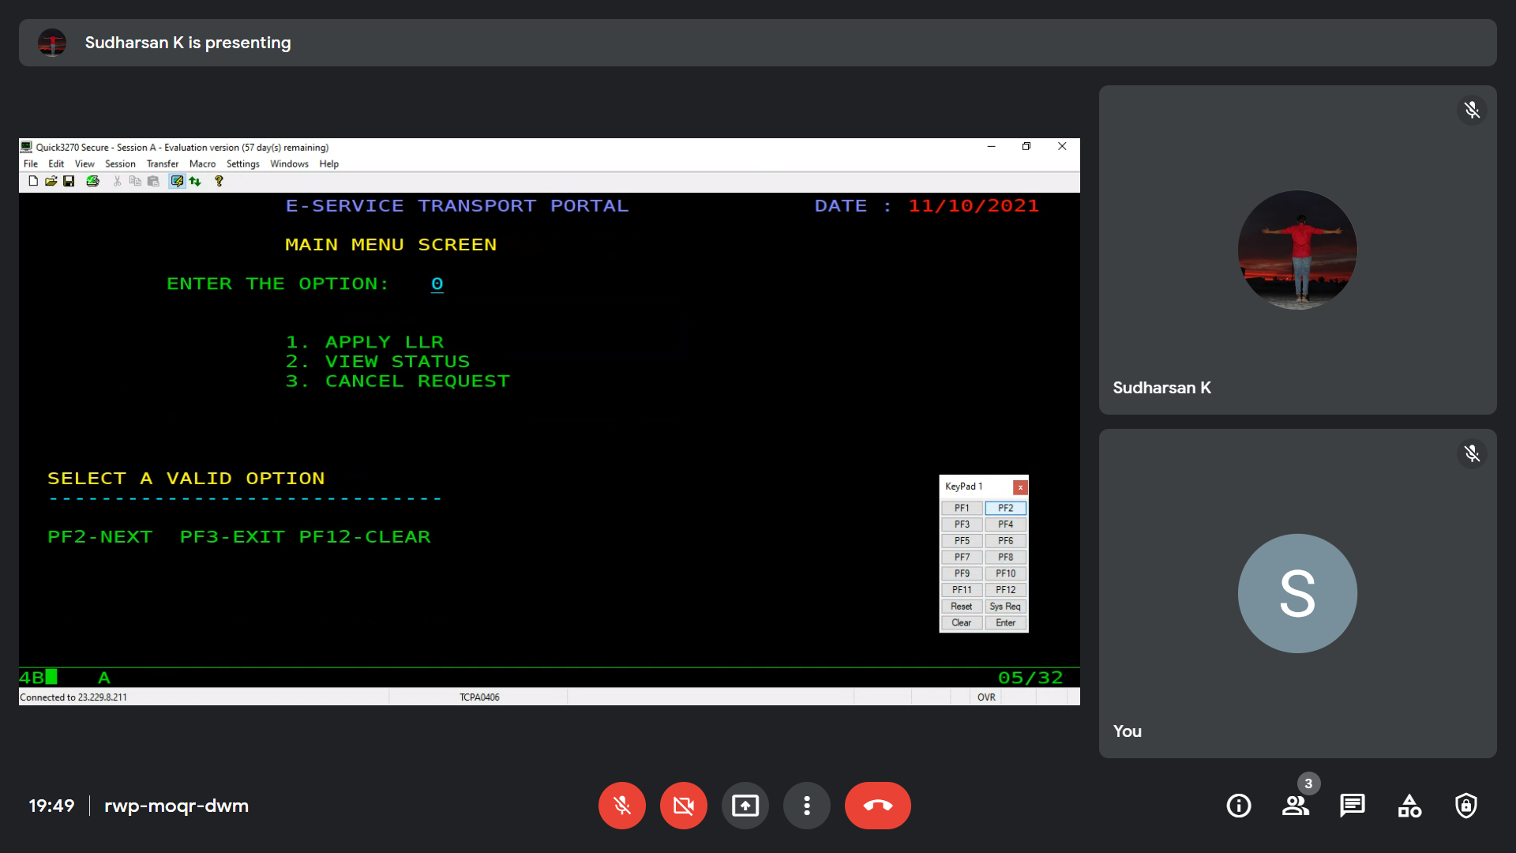

* 1. SC1MAP – INVALID PFKEY

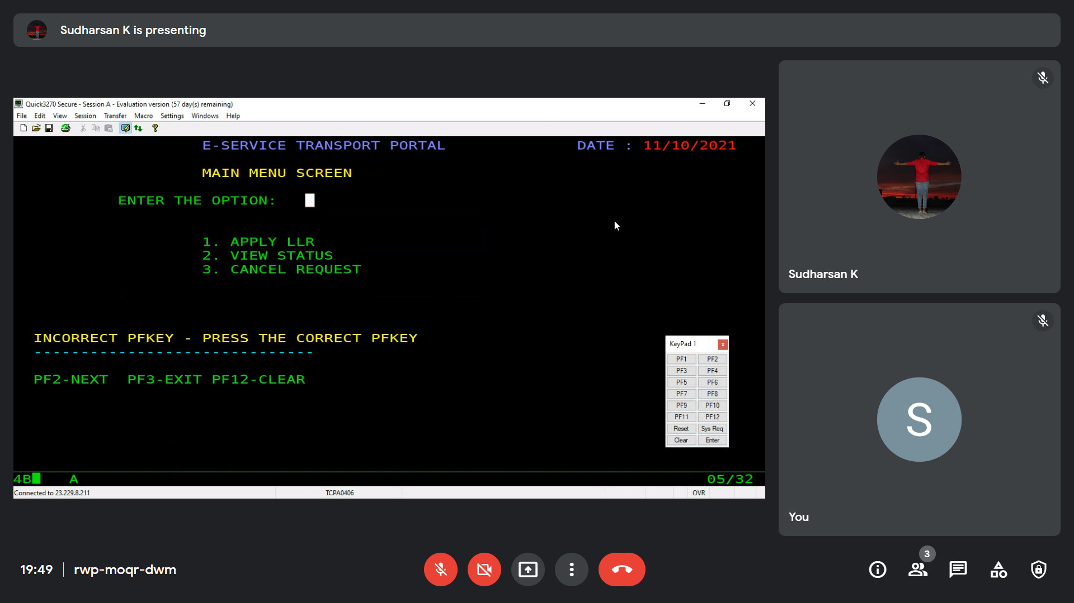

* 1. SC1MAP TO SC2MAP – OPTION 1 PRESSED

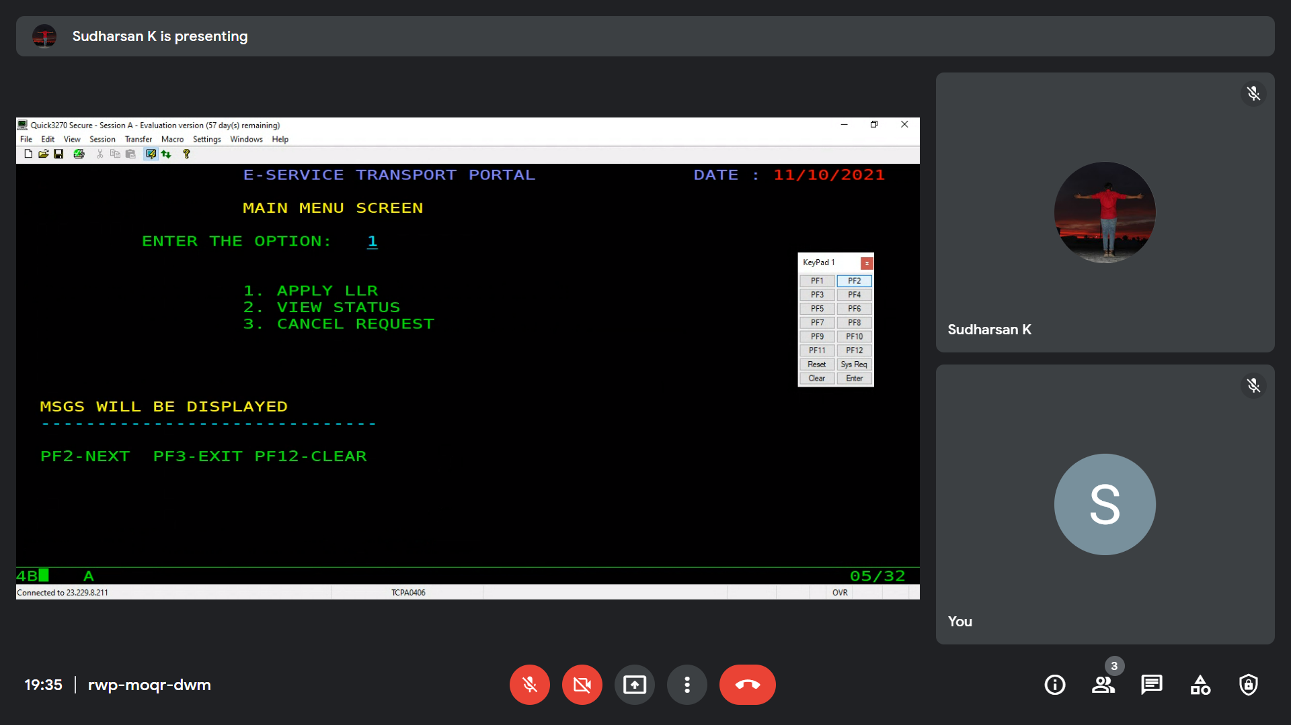

1. SC2MAP

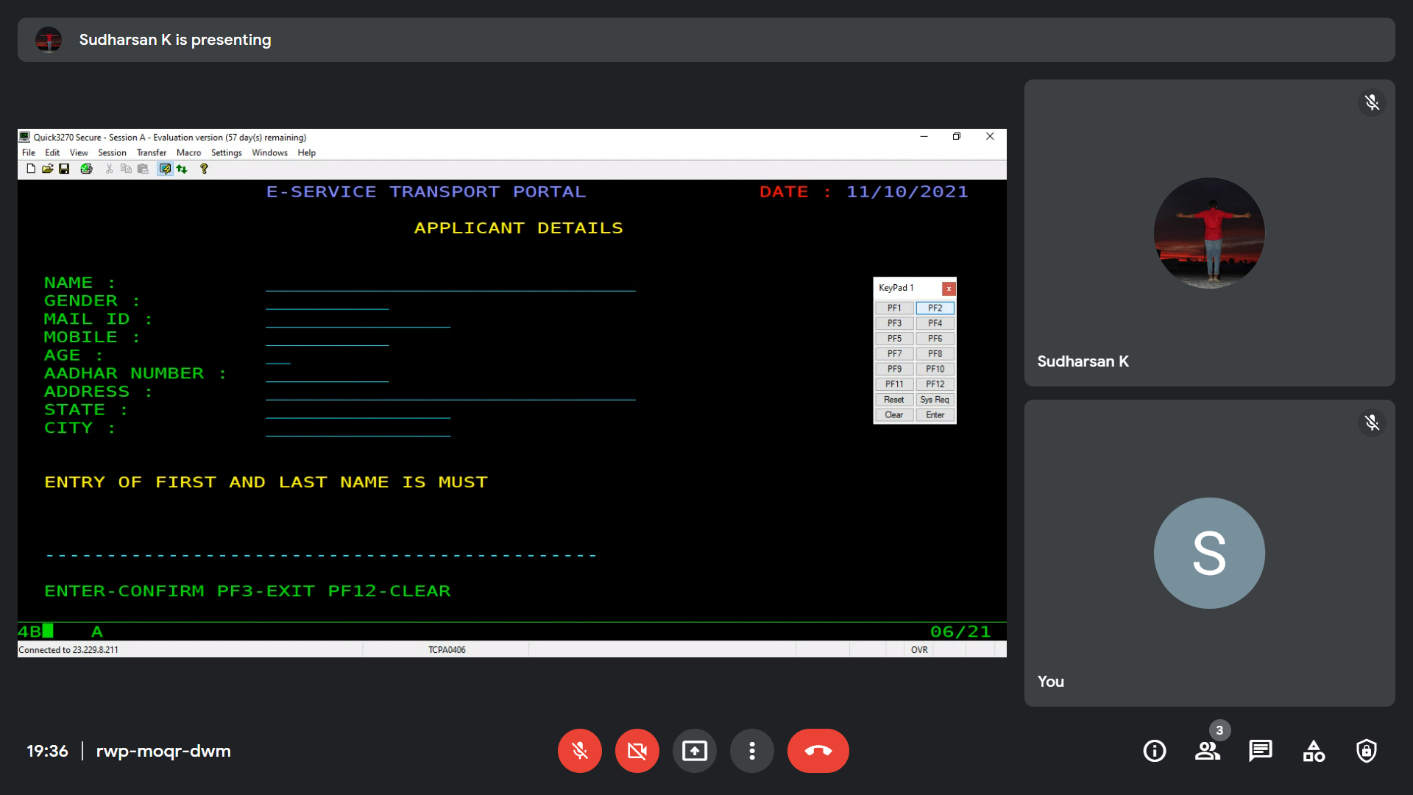

* 1. SC2MAP – NULL MAP SENT

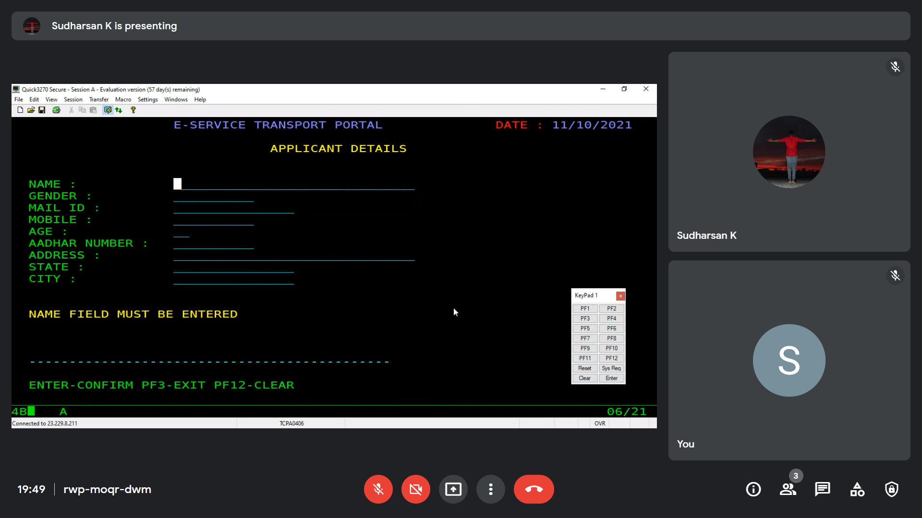

* 1. SC2MAP – VALIDATIONS

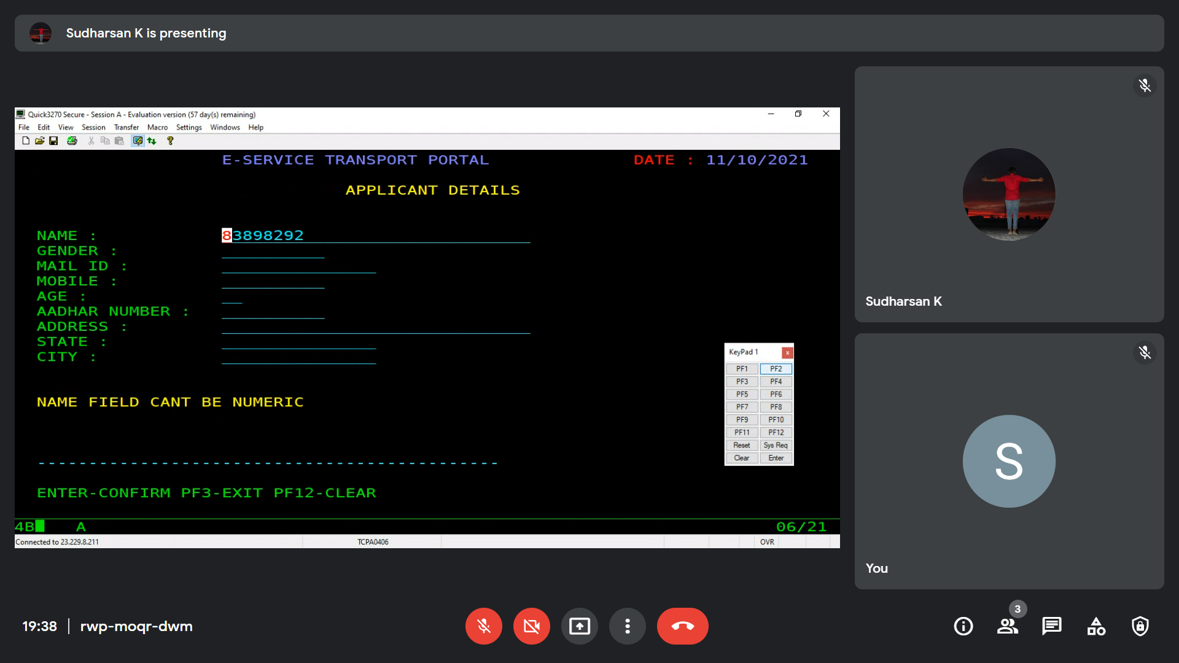

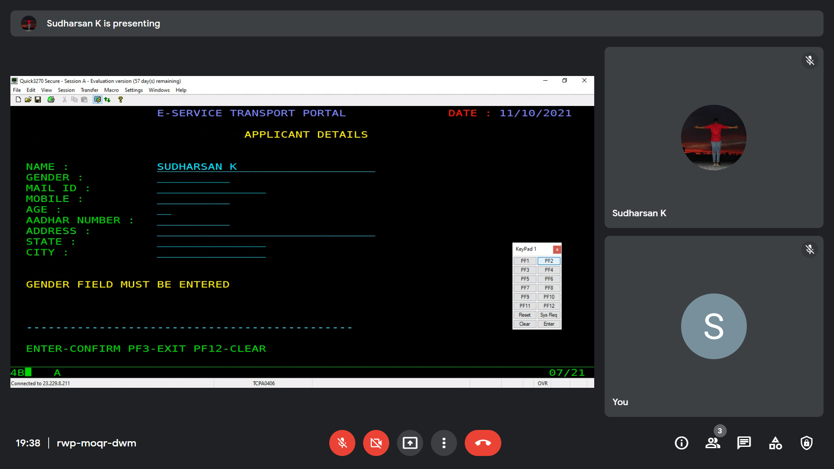

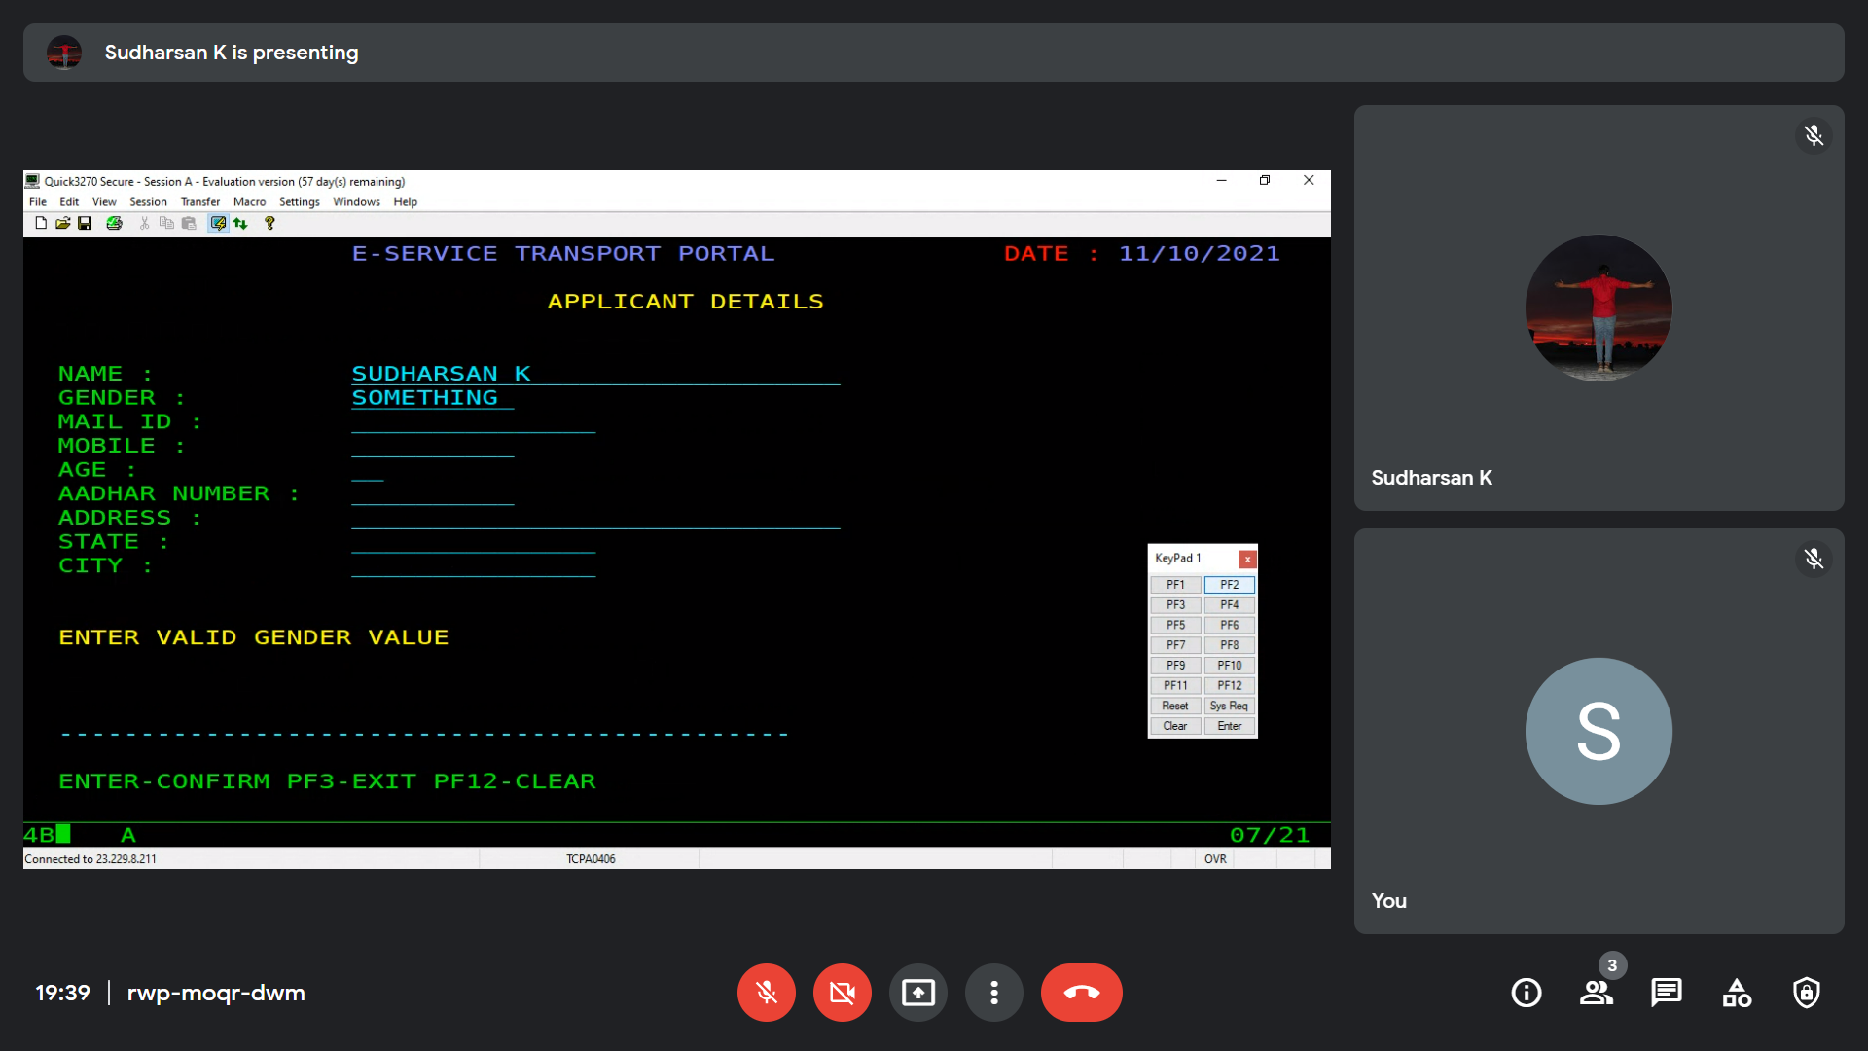

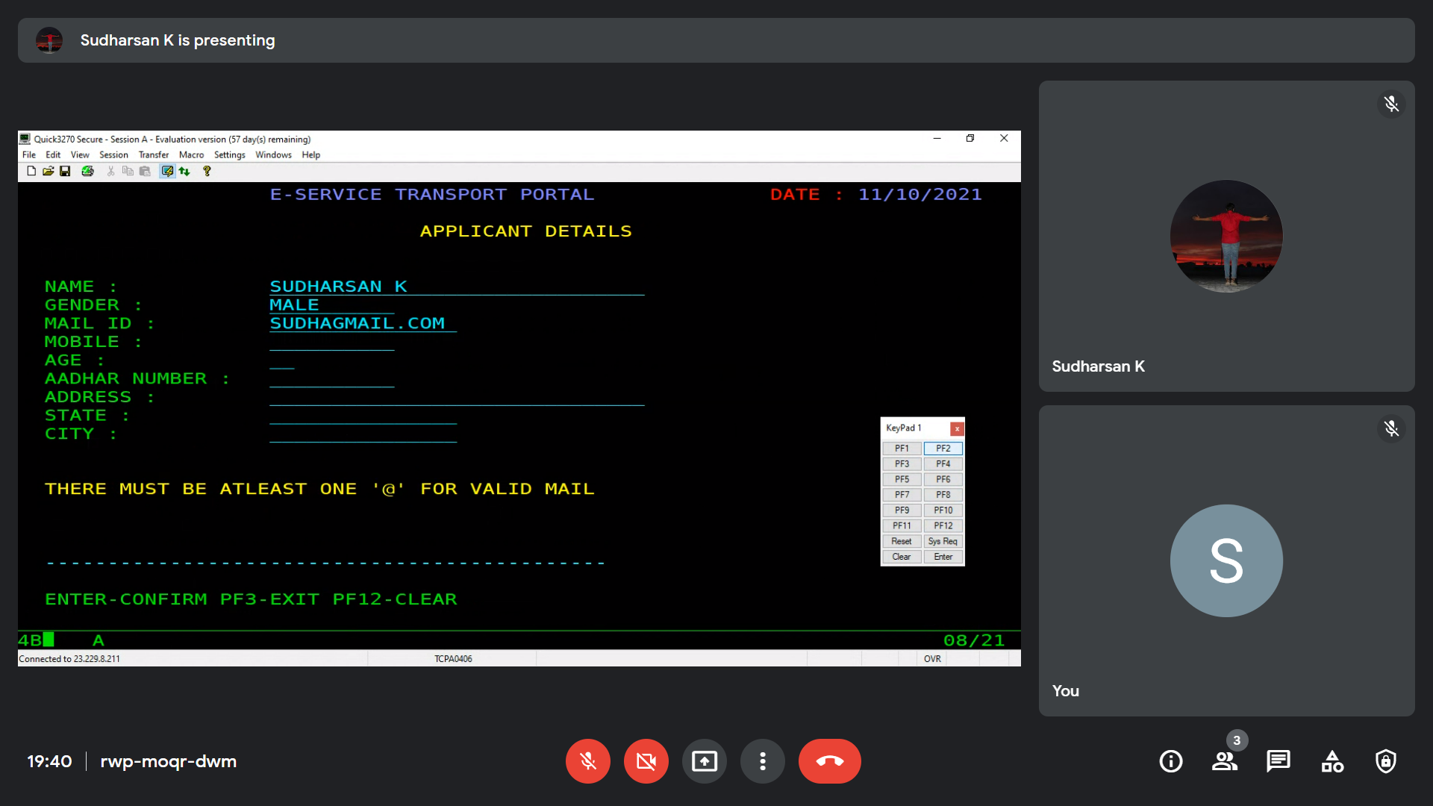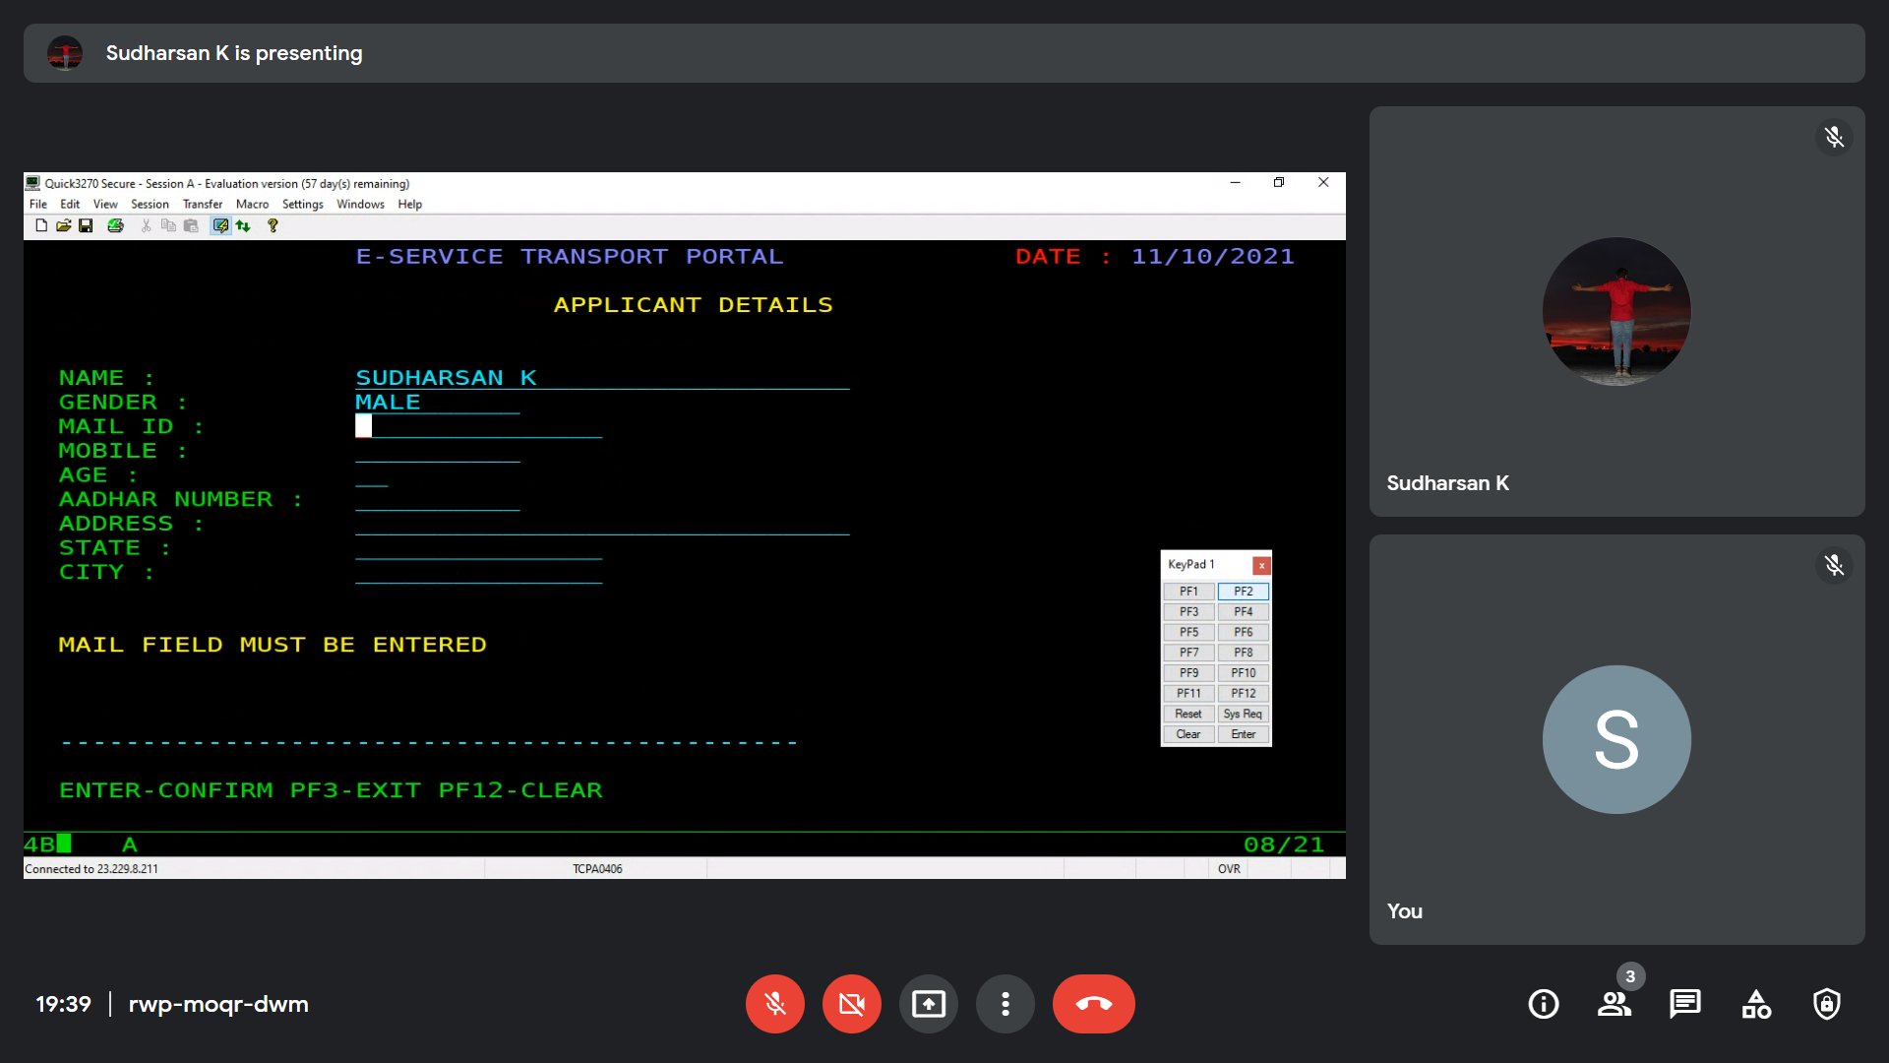

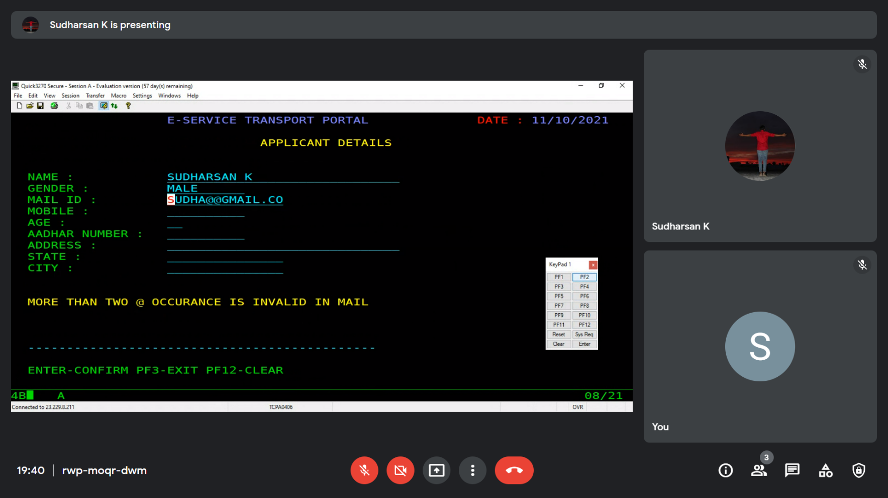

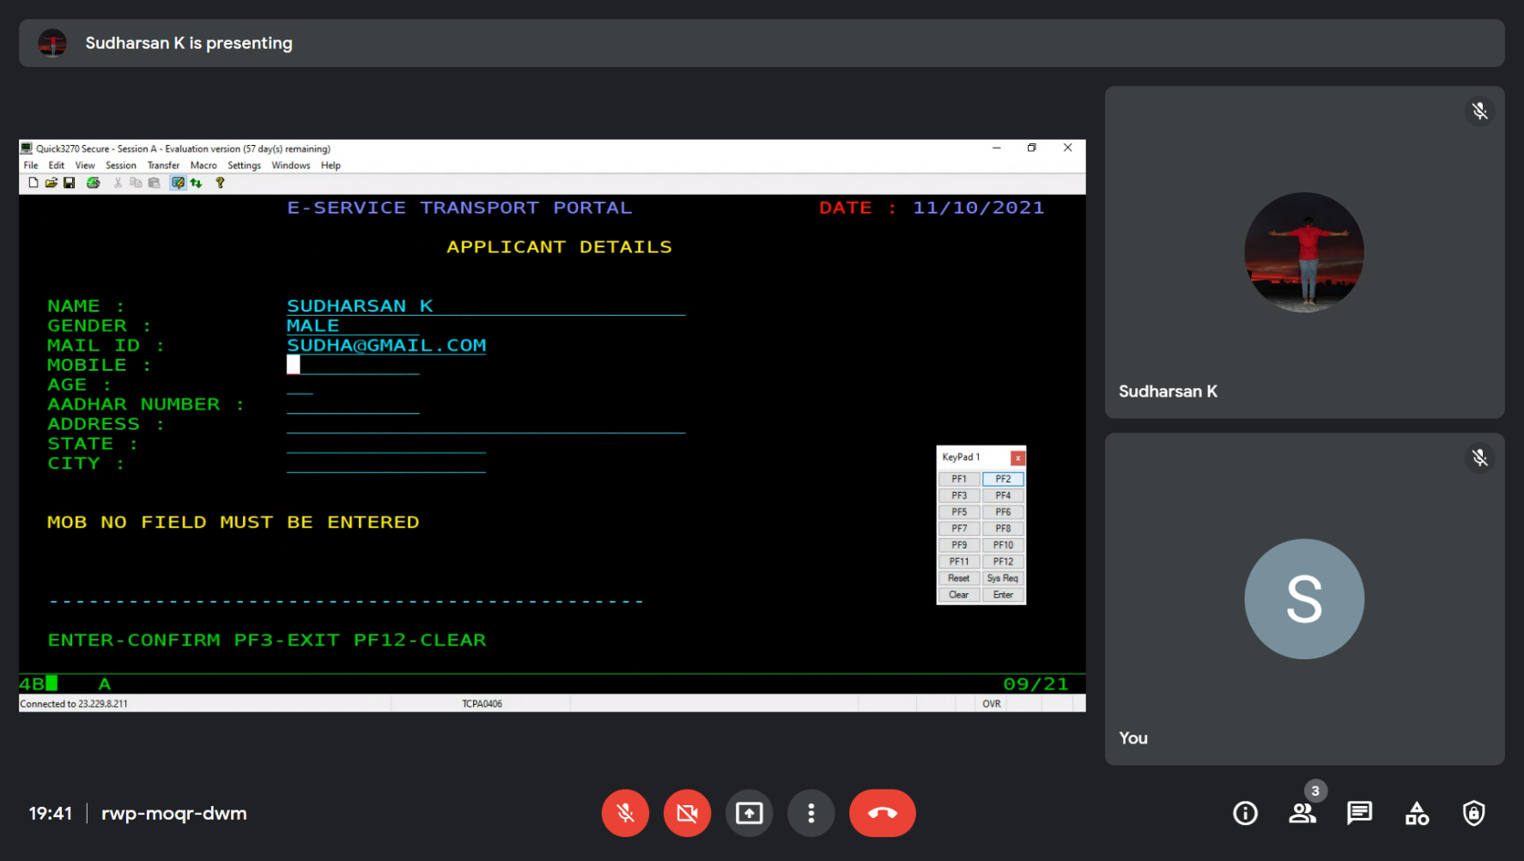

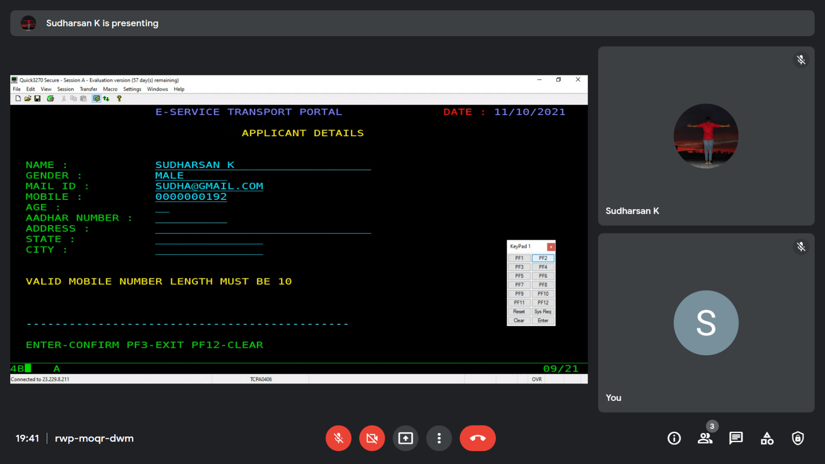

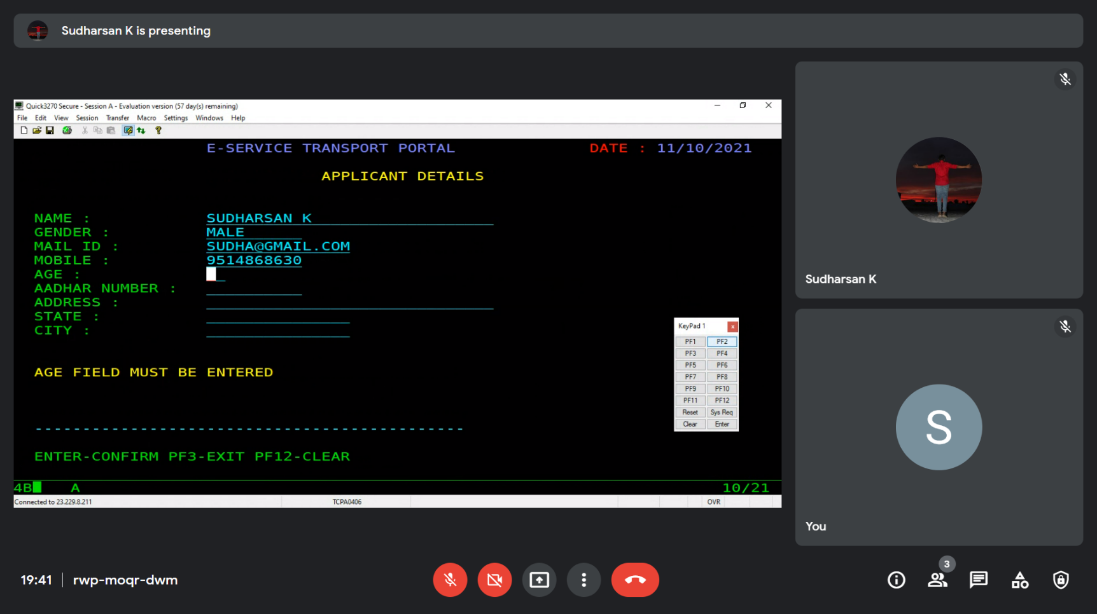

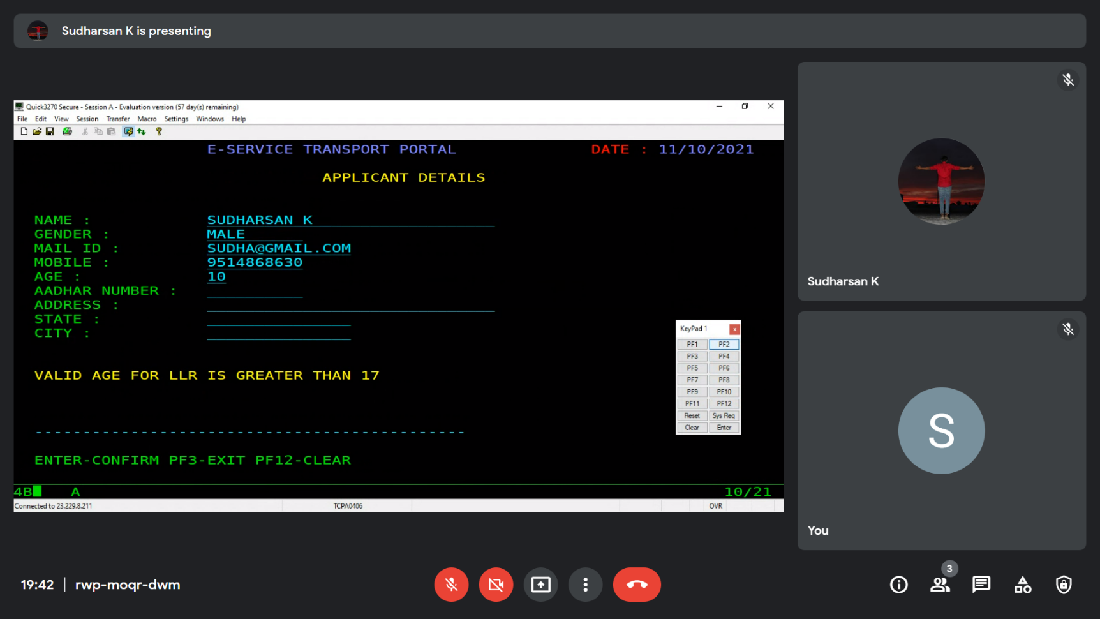

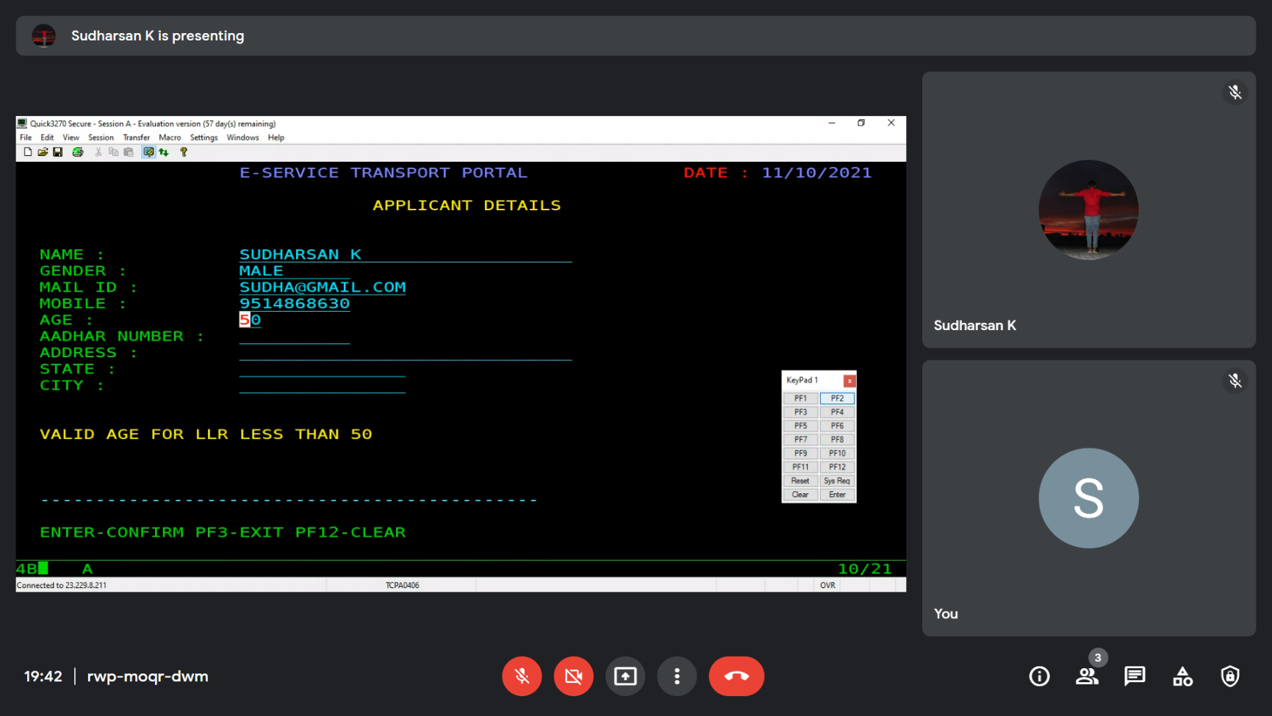

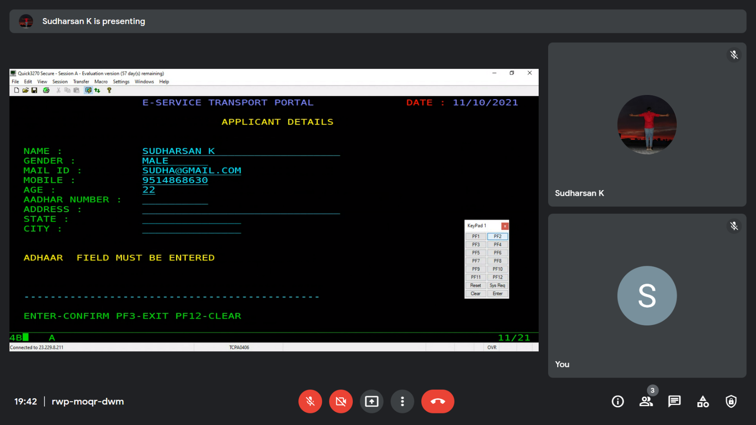

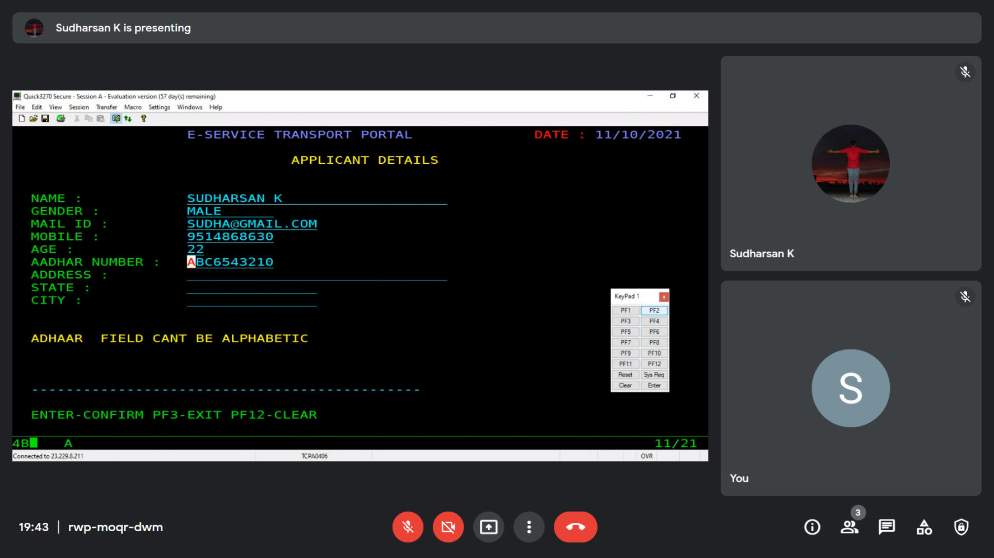

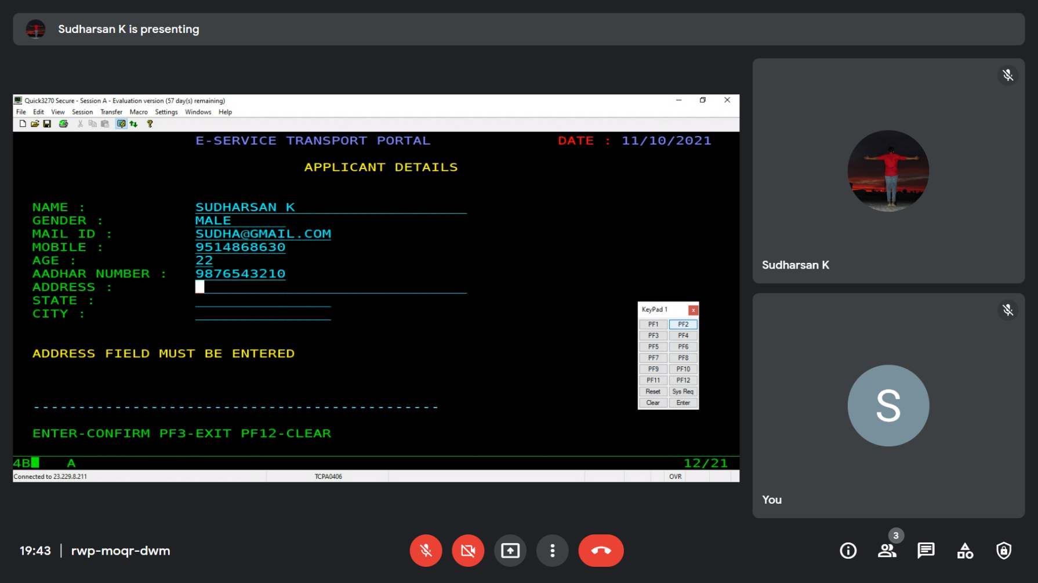

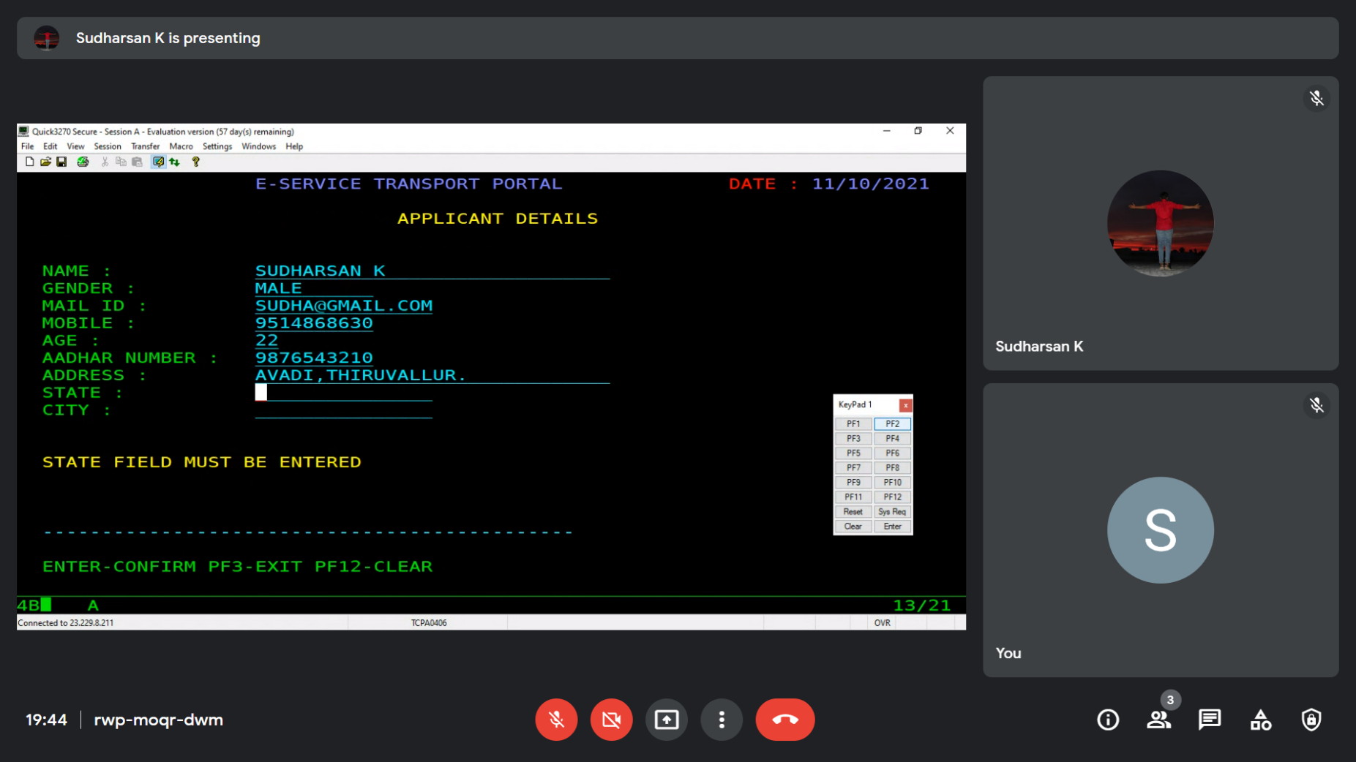

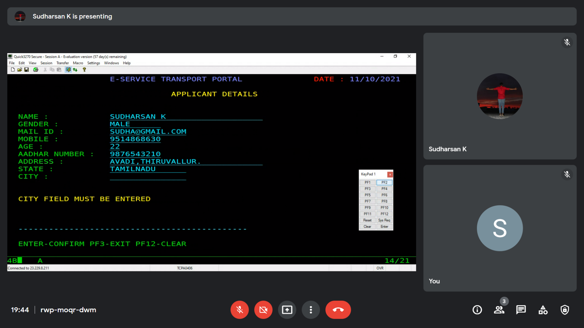

* 1. SC2MAP – DUPLICATE VALUES

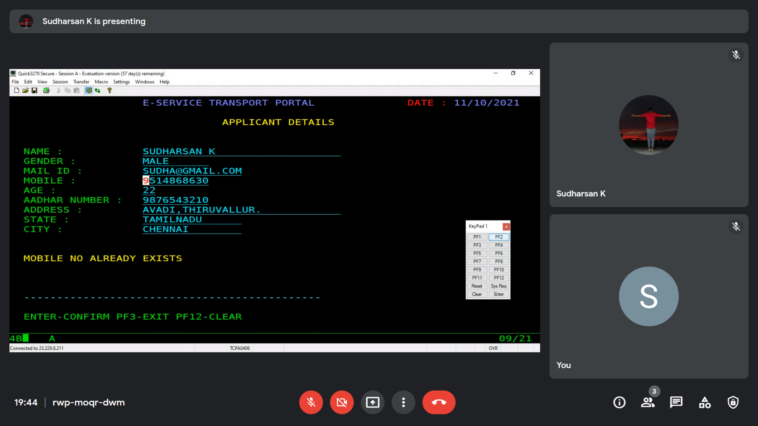

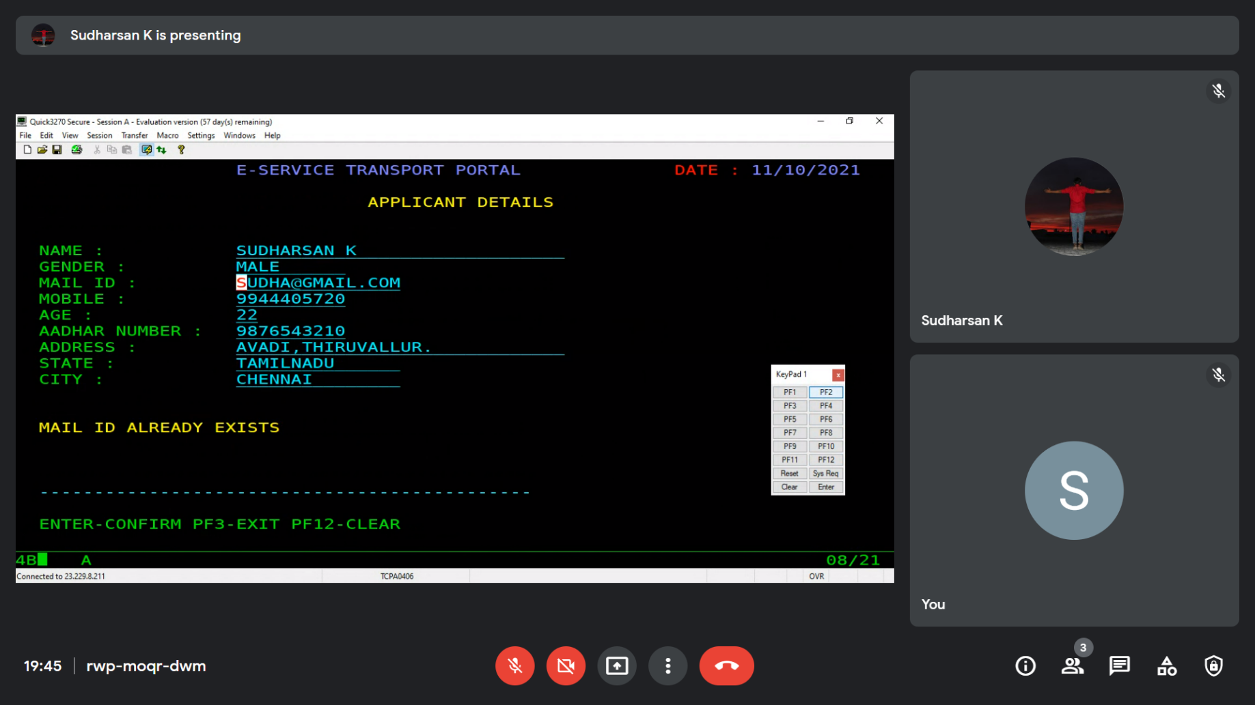

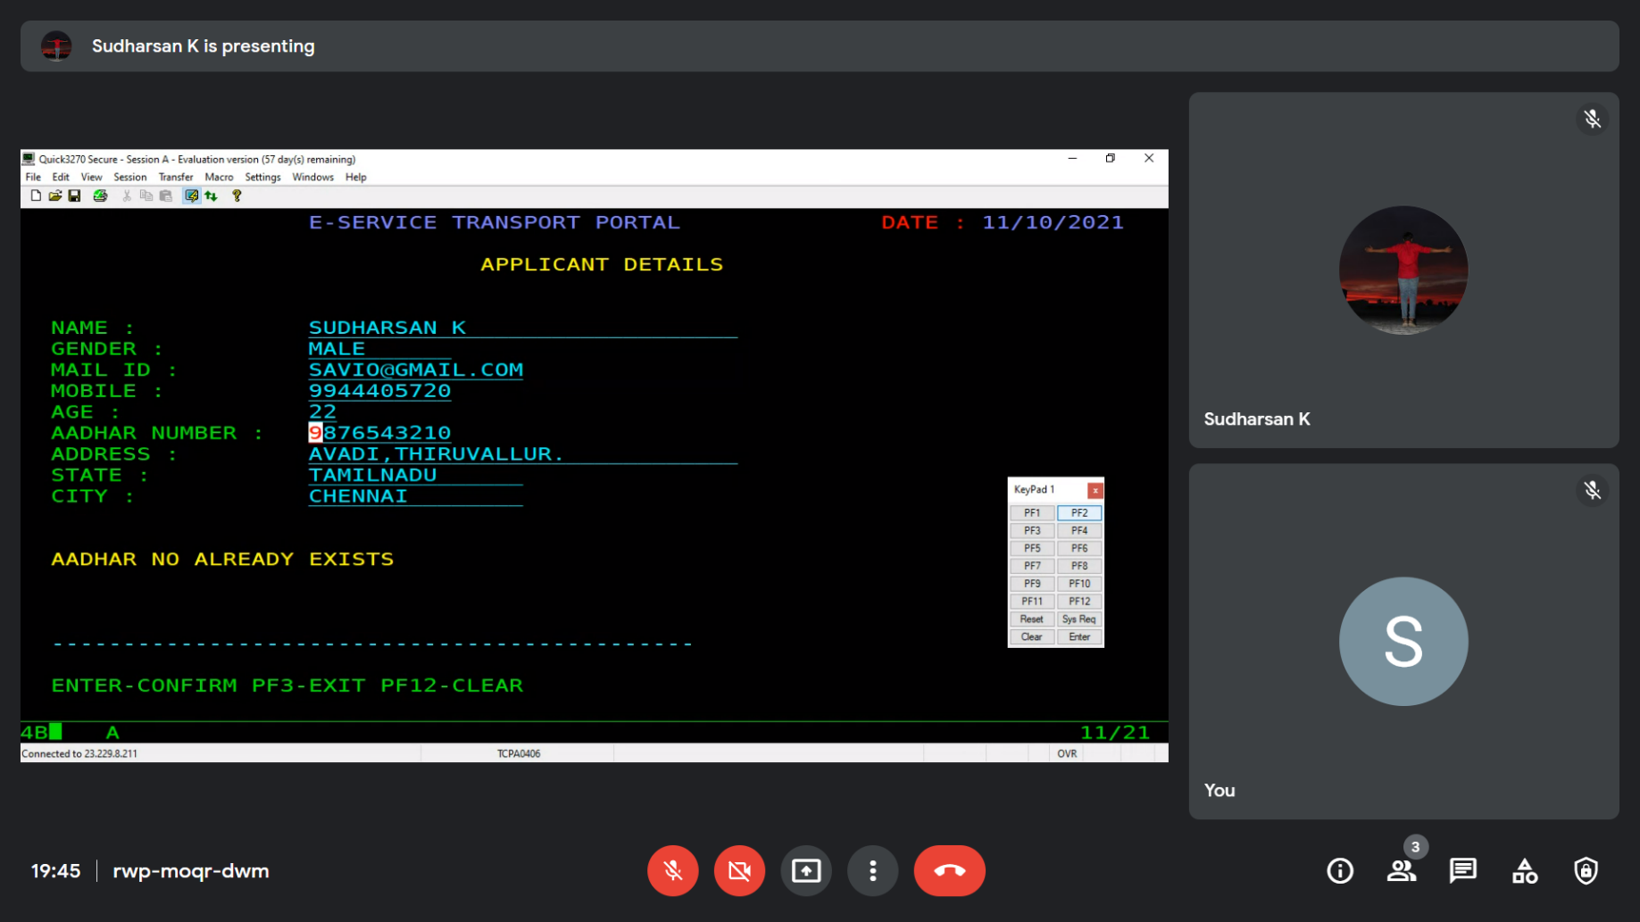

* 1. SC2MAP – SC3MAP – APPLICATION SUBMISSION

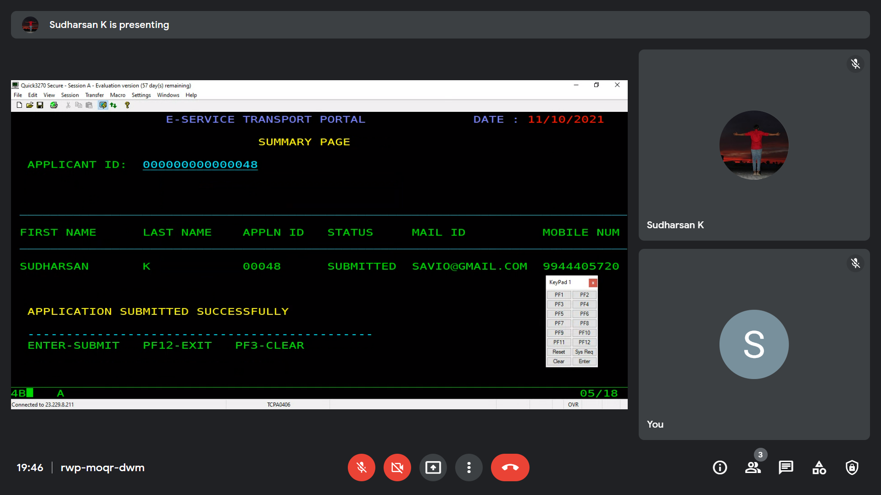

* 1. SC2MAP – INVALID PFKEY

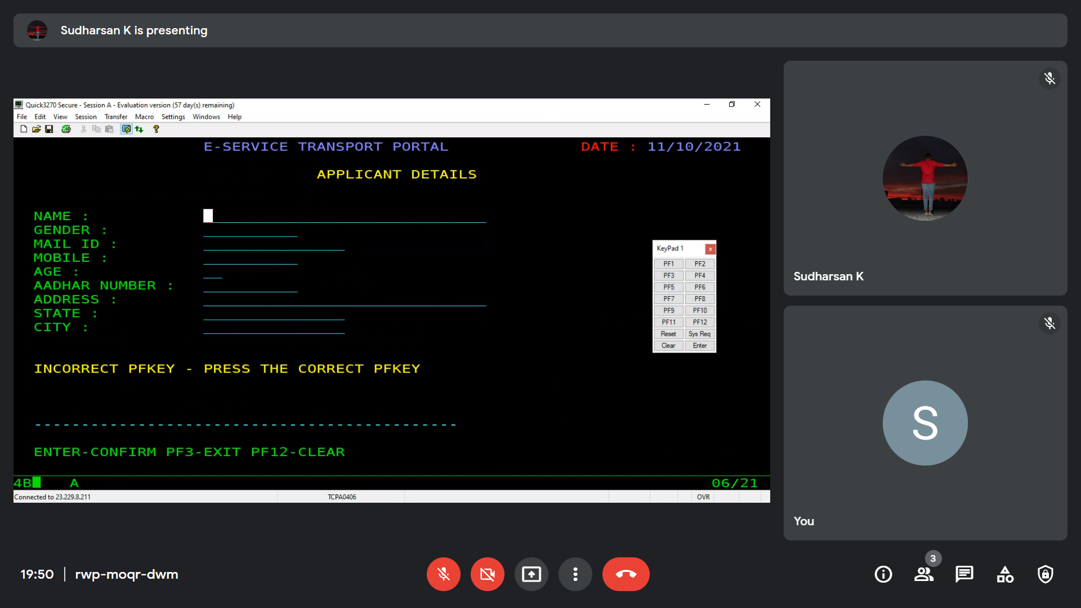

1. SC1MAP TO SC3MAP – OPTION 2 PRESSED

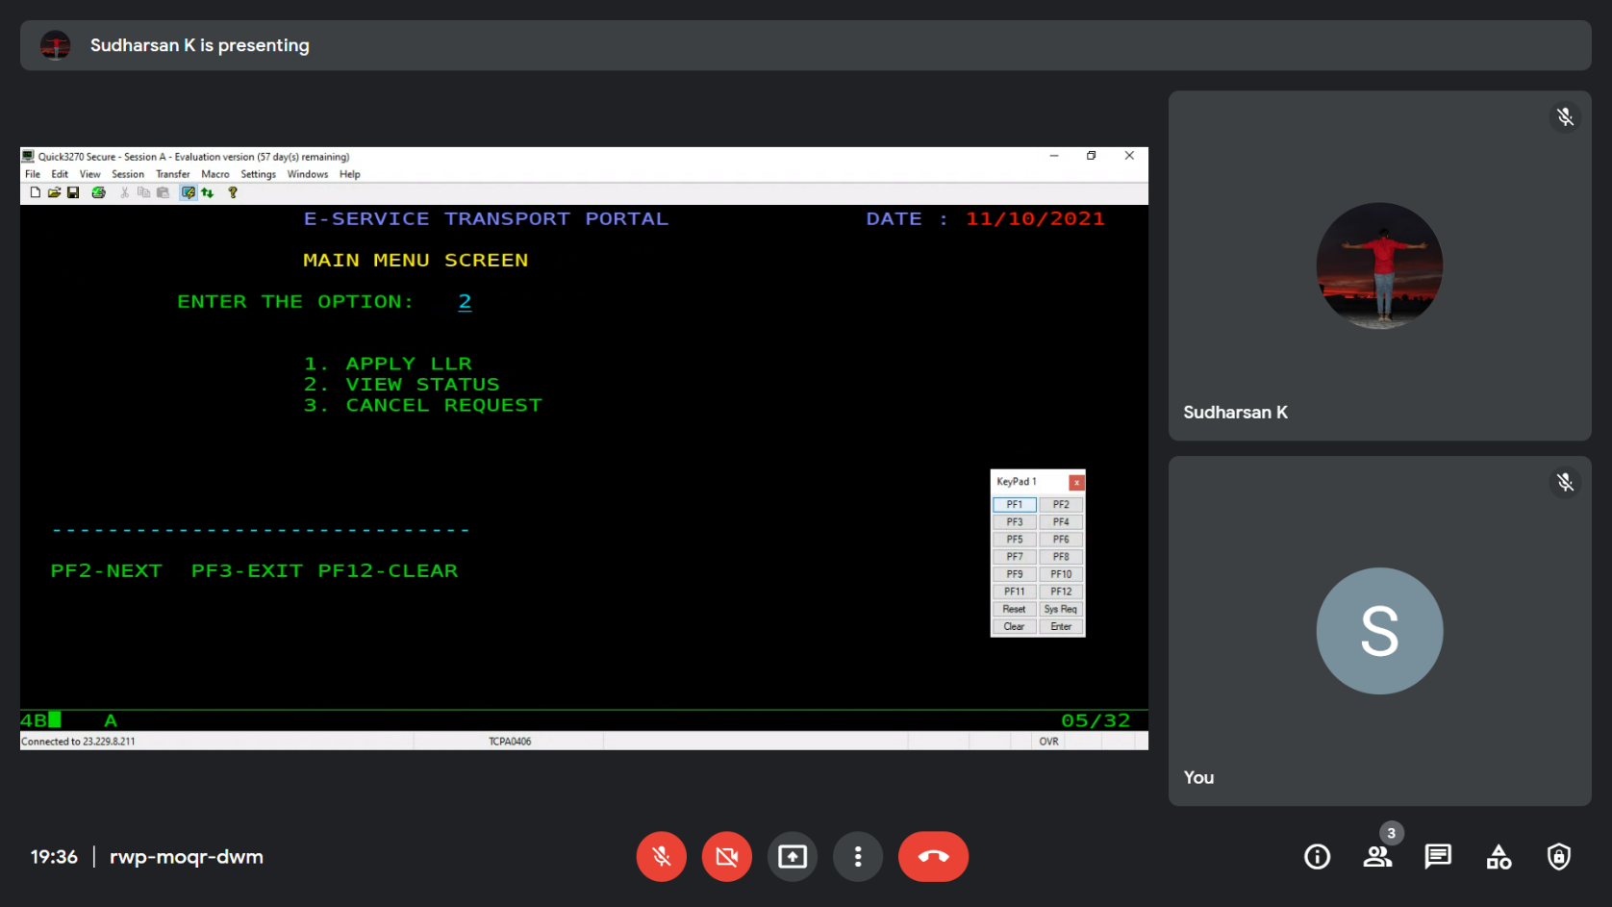

* 1. SC3MAP

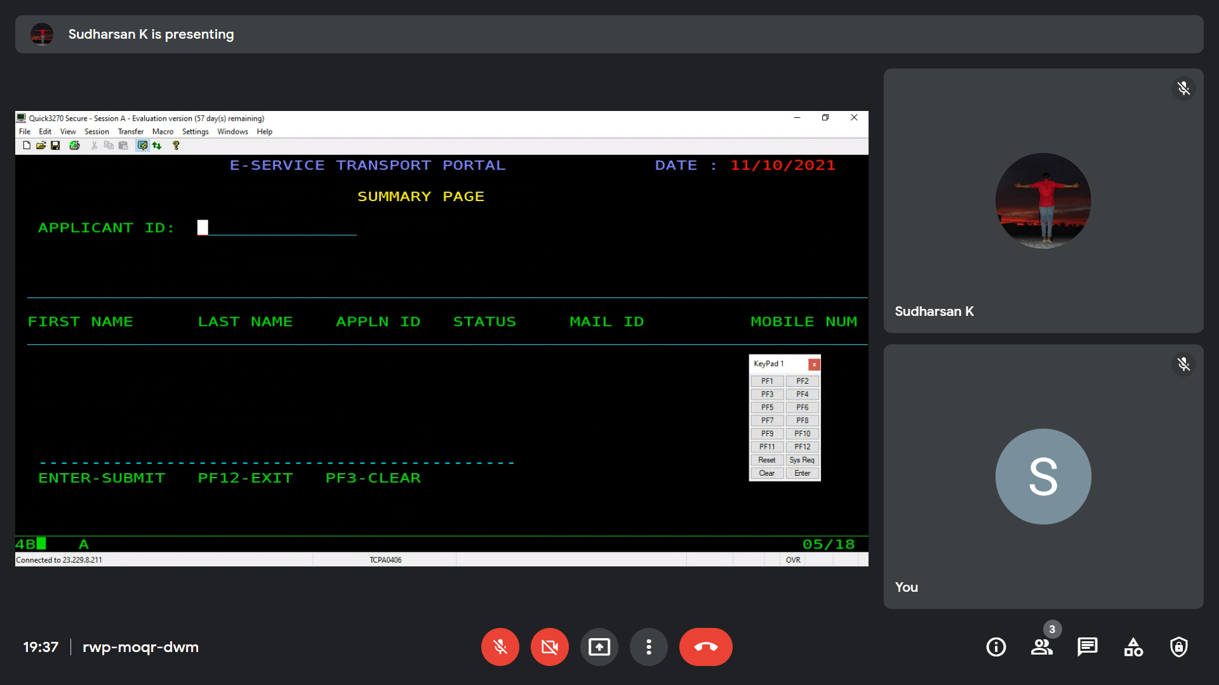

* 1. SC3MAP – NULL MAP SENT

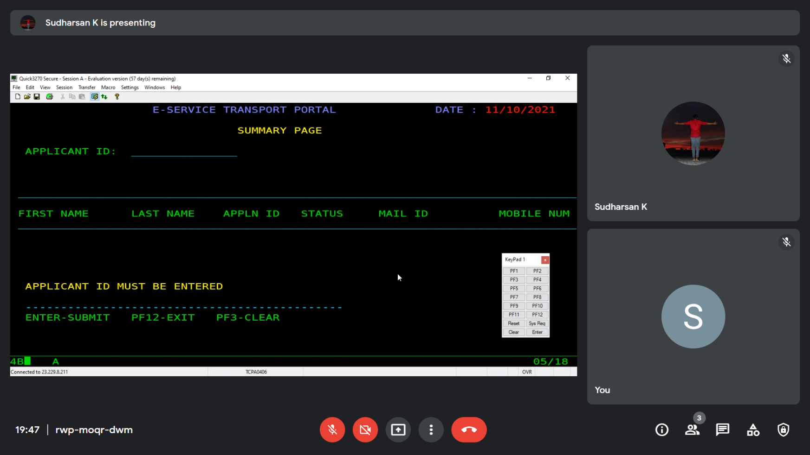

* 1. SC3MAP – DISPLAY RECORD

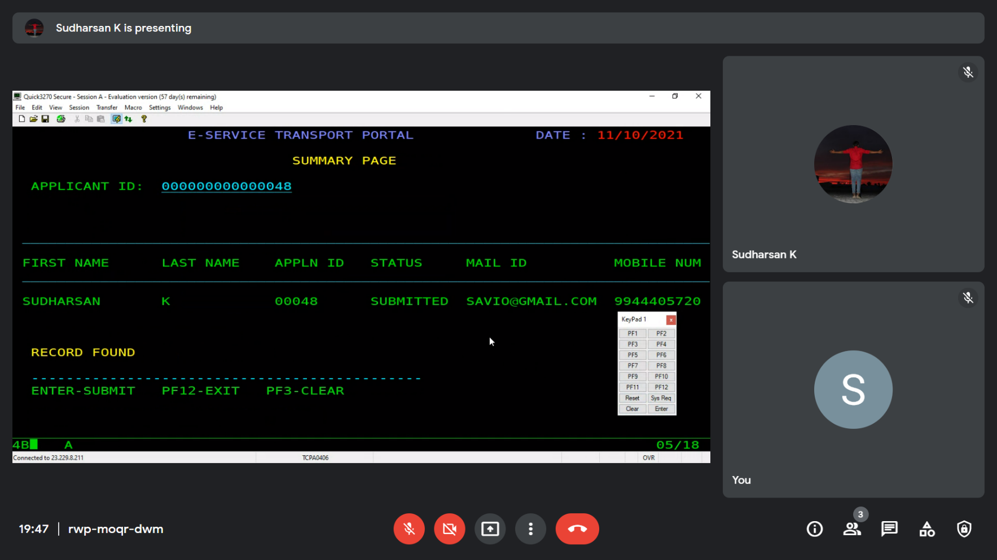

* 1. SC3MAP – INVALID APPLICANT ID

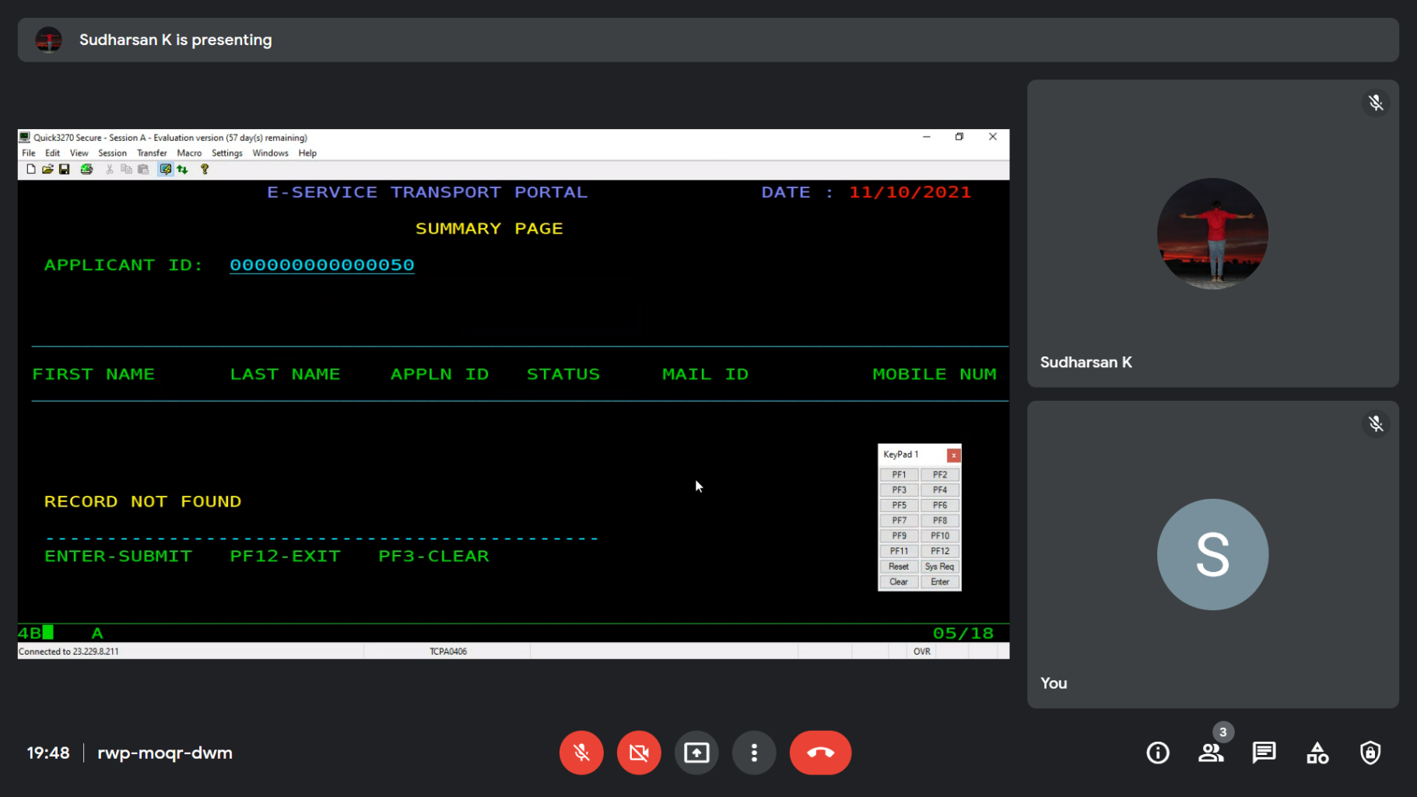

* 1. SC3MAP – INVALID PFKEY

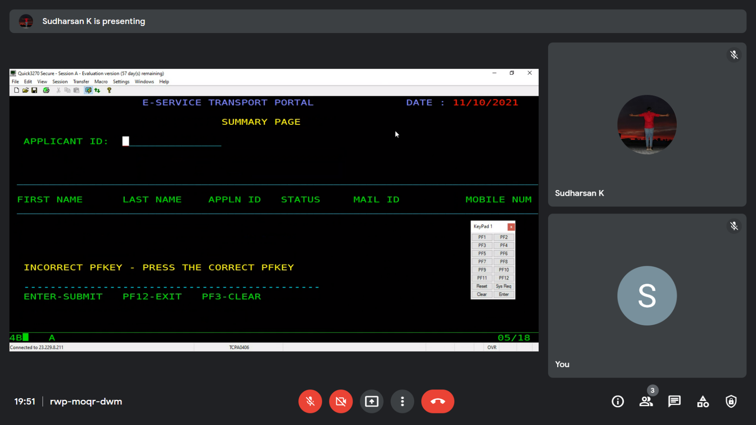

1. SC1MAP TO SC4MAP – OPTION 3 PRESSED

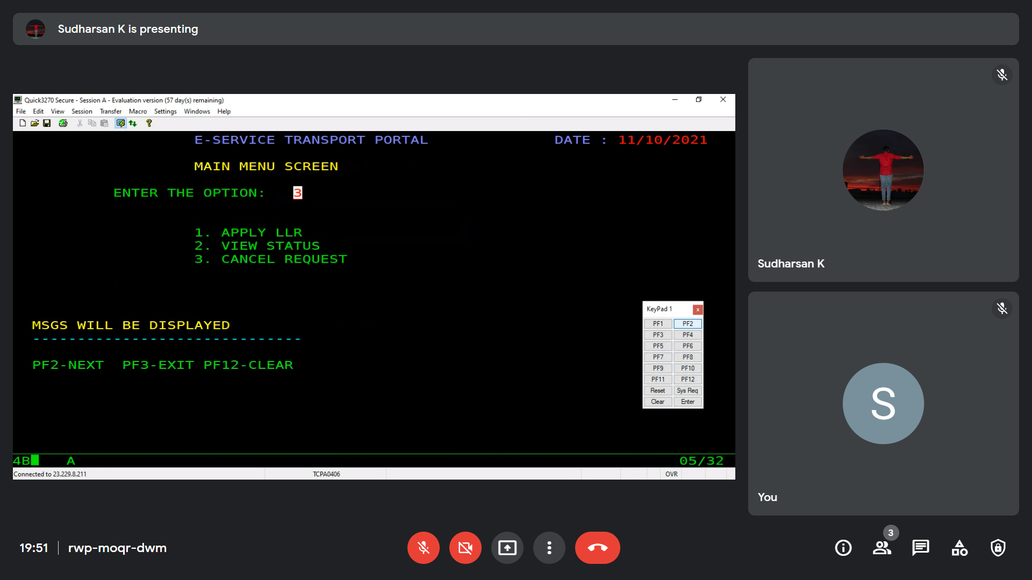

* 1. SC4MAP

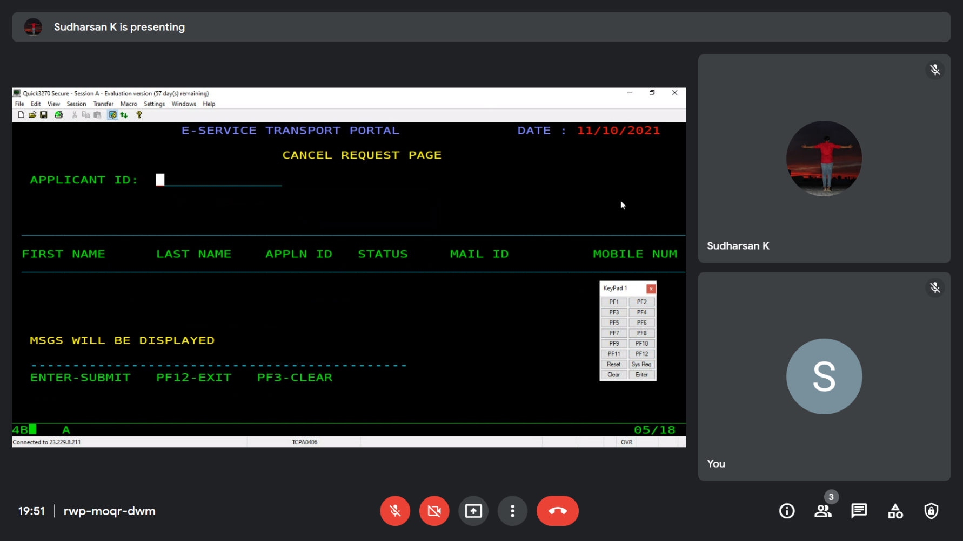

* 1. SC4MAP – CANCEL APPLICATION

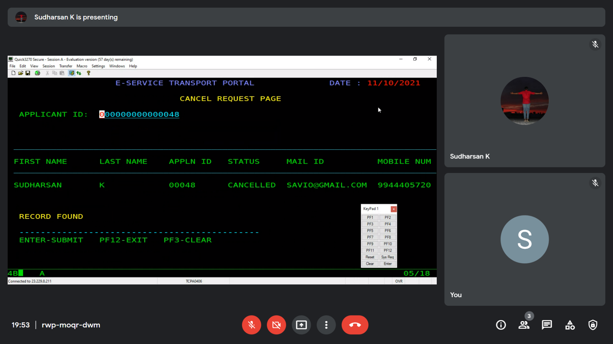

* 1. SC4MAP – REQUEST CANCEL FOR CANCELLED APPLICATION

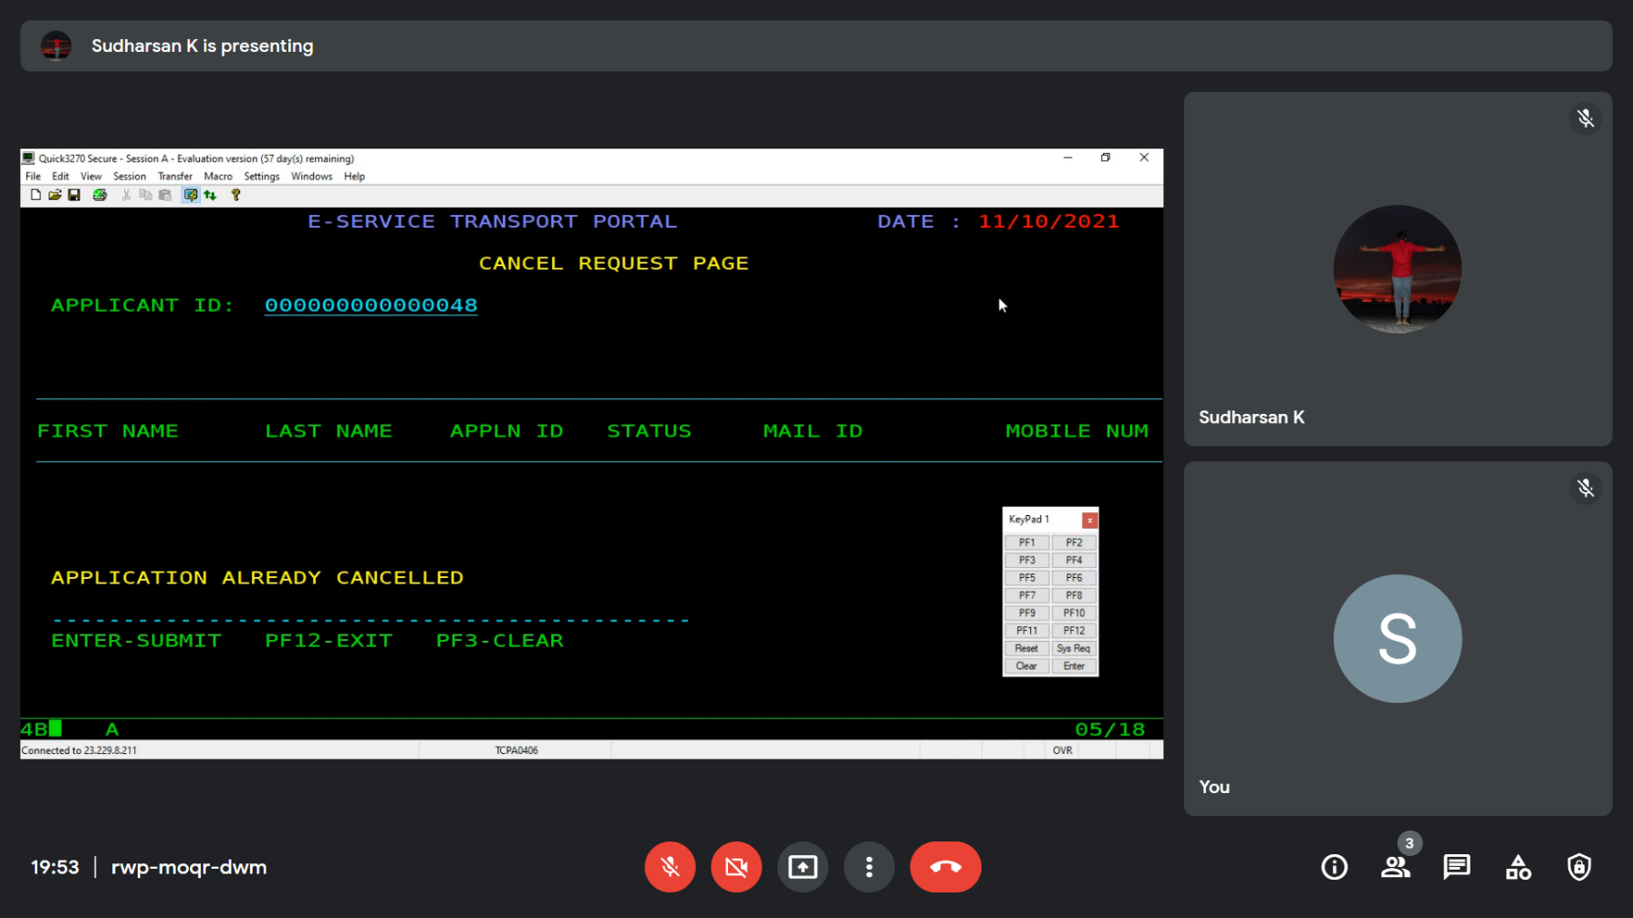

* 1. SC4MAP – INVALID PFKEY

